River Chess Smarter Water Catchment Landowner and Farming Grants Application Form

Before you begin:
- Read and understand the application guidance. You can find more information in the ‘Guidance for Applicants’. ‘Guidance for Applicants’

The application form
The application form is made up of a number of sections. Please ensure you fill in all the required sections.

Required

Before you begin | Consents and Permissions
Section 1 | Applicant details
Section 2 | Project details
Section 3 | Project application
Section 4 | Project costs
Section 5 | Declaration and close of application
Supporting documents

Annex A | Project costs table

Before you begin
Consents and Permissions
Before you apply for your project, you must make sure that you will be able to obtain all the consents and permissions required.
You are responsible for arranging all relevant consents, permissions, exemptions and written advice needed for your application. You will not be offered an agreement without all the necessary consents and permissions being in place.
To make sure you submit a valid application:
- identify the consents and permissions you need as soon as you start your
application. This will depend on any designations attached to the land included in the application and on the activities and items that you are applying for in your application.
- contact relevant organisations for advice and consents, where required
- be able to provide the Catchment Manager with the evidence needed to support your application.
You may be unaware of some of the consents and permissions you need until after you have received advice. You should talk to the Catchment Manager about the relevant organisations to contact for advice and to gain consent or permission.

Section 1: Applicant details

Main contact

Full name

Daytime telephone number

Email address

Business name

If a collaborative application, please list the lead farmer (the contract holder's) name
Position in business

Business address

If a collaborative application, please list the lead farmer (the contract holder's) address and postcode
Business postcode

Website address (if applicable)

Is your land holding located in an area classified as a Severely Disadvantaged Area (SDA)?  Please tick | Yes
 | No
What is the size of your total land holding(s) (in hectares)? | ha
Which option best describes you?  Please tick. | Landowner
Which option best describes you?  Please tick. | Tenant
Which option best describes you?  Please tick. | Other (please state)
What are the main activities of your business?  Please tick all that apply | Dairy
 | Sheep
 | Beef
 | Arable
 | Forestry
 | Public access
 | Diversification
 | Other (please state)
Have you or your business previously received funding from the Chess Smarter Water Catchment programme?  Please tick yes or no | Yes
 | No
 | Is yes, please specify the total amount of the SWC grant(s) received and the project title.
To help us publicise the programme in the future, please tell us how you first heard about it.  Please select one option only for our reporting purposes.  Please tick | Word of mouth
 | Website
 | Event/ Meeting
 | Social media
 | Newsletter
 | Other (please state)

Section 2: Project details

Location of this project

You will need to ensure that you attach a map of the project to your application. Where possible, the map will need to include the holding boundary and the location of the items/activity for which you are requesting funding.

Location postcode (required)

If you have an SBI number:  Please list the single Business Identifier (SBI) number of the holding and/or of the land involved in the application and the Parcel ID(s) of all the land involved in the application.  Please state in RLR format (e.g., AB1234 5678). | SBI |  | Parcel ID - RLR
 | Please insert new rows if necessary
The land where this project is being delivered

If this project will be delivered on a farm/land, please provide the area in hectares of the farm holding where the project activity will be delivered. |  |  | ha
Double funding

A project cannot receive funding for activities or works that are already being funded by another Government scheme or programme as this would be double funding. This could include activities or work that you are applying for or have previously received funding from another Government scheme or programme.

You also cannot receive funding for activities or works that are sold, or intended to be sold, for environmental credit schemes such as BNG.

Have you (or the owner or tenant of the land affected by the application) received or applied for any other funding for the same activities or works that you are applying for in this programme?  Please tick |  |  | Yes
 |  |  | No
If yes, please provide details of the other scheme or programme. Your Protected Landscape will need to explore the reason for your response with you further.

Other funding Scheme(s)/ programme(s) type

Date(s) of other funding scheme/ programme

Protected Sites

Will this project be delivered on a protected site, for example a SSSI or Local Wildlife Site?  Please tick |  |  | Yes
 |  |  | No
If yes, please provide details of the site and protection.

Name of Site

Site reference (if known)

Type of protection

Section 3: Project application

This project

Project title

e.g. Habitat creation and water quality improvement at Home Farm

Please give a short description of this project

e.g. Planting 300m hedgerow with hedgerow trees, sow 30ha of wildflower meadow and restoration of 2 dew ponds

Expected start date

DD/MM/YYYY
Expected completion date

DD/MM/YYYY
Project Outcomes

Project summary

A description of this project.
Please provide an overview of your project.

Please tell us about your project ensuring that you cover all the activities that will be part of your project and each stage that will be taken for this project from start to finish.

What is the demand for this project and need for delivering it in the proposed location?

What do you expect this project will achieve?

Delivering on the Catchment Plan

This project must contribute towards the priorities of the Chess Smarter Water Catchment programme.

Your Catchment Manager can provide further advice and guidance to help you complete this section.

How will this project contribute towards the Catchment Plan for the River Chess with reference to specific objectives?  [link to Catchment Plan- page 8 lists objctives] | ☐ Improving Water Quality  ☐ Managing Flow  ☐ Nature Recovery  ☐ Working Together

National targets and outcomes

Your project may also contribute towards the following targets and outcomes:
- Protected Landscapes Target and Outcomes framework
- Local nature recovery strategies - GOV.UK

Please complete this section if your project aims to meet any of these targets and outcomes. Your Protected Landscape will provide further advice and guidance to help you answer this section.

The county Local Nature Recovery Strategies (LNRS) are available here:

Bedfordshire | https://bedslocalnaturerecoverystrategy.commonplace.is/
Buckinghamshire | https://bucksmknep.co.uk/nature-strategy/local-nature-recovery-strategy-for-buckinghamshire-and-milton-keynes/?preview=true
Hertfordshire | https://www.hertfordshire.gov.uk/about-the-council/how-the-council-works/partnerships/herts-nature-recovery-partnership/local-nature-recovery-strategy.aspx
Oxfordshire | https://www.oxfordshire.gov.uk/residents/environment-and-planning/local-nature-recovery-strategy-lnrs

Contribution to the Protected Landscapes Target and Outcomes framework  (list target number and its description that will be delivered by the proposed activity) | e.g.  Target 10  Decrease the number of nationally designated heritage assets at risk in Protected Landscapes.
Contribution to the Local nature recovery strategies - GOV.UK (LNRS) priorities in the Protected Landscape

(describe the activity that will contribute to LNRS)

Ability to deliver
Who will be involved in delivering the project?

Please explain how they will contribute to the project’s delivery.

How will you ensure that the project delivers to your anticipated timeframe and within each financial year?

Please make clear the steps you will need to take to achieve your key milestones and successfully deliver your project.

Sustainability and legacy of projects
What will happen to the project once the funding ends?

Describe how the project will:
- have a lasting positive impact for the Protected Landscape and others
- continue for the longer term
- increase the sustainable resilience of your farm/land management

Evaluation

In submitting this application, you confirm that you will work with your catchment manager to participate in a proportionate project evaluation and, if required, feed into programme evaluation led by the programme external evaluation team.

Section 4: Project costs

Please complete Annex A.
You must discuss the project and seek support from your Farming in Protected Landscapes officer to complete this section.

Project costs and funding

Quotes

If any of your project costs are based on an actual cost basis, please list the quote(s) you have or the sources of benchmarked cost(s) in the Application Template Annex A. You must include copies of the quote(s) / benchmarked cost(s) with your application.
Where an activity has a CS equivalent, costs must be at the same payment rate and the same intervention rate. Please ensure you make clear why the chosen specification and costs are necessary to achieve the project outcomes. Funding will be based on the lowest quote. Where the chosen supplier of a product or service is not the cheapest available, please also provide a clear explanation as to why you have opted for the higher quotation.
Match funding

If this project includes any match funding, please describe what this is and attach details including value, terms and source(s) of funding with your application.
Please provide an indication of any in kind match funding anticipated.
The total value of the match funding should be entered in both Annex A and the Project Funding Summary table in this application template.

VAT

If you are able to reclaim VAT from HMRC, please exclude VAT from the figures given in this project costs section and Annex A.

If you are not VAT registered, you will be able to include VAT in the project costs and your grant request.

Are you VAT registered? |  |  | Yes |  |  |  | No
If yes, please state your VAT number.

Project funding summary

You must ensure you complete Annex A to provide a full account of your costs to accompany your application.

To note: “Match Funding” applies to third party funding only and does not include any contribution of your own funds to the project.

Description | 26/27 | 27/28 |  | 28/29 |  | 29/30 | Total
Total Match Funding (£)

Total SWC Grant Request (£)

Total Project Cost (£)

Section 6: Declaration and close of application
I declare that the information given in this application is correct to the best of my knowledge, and that if any of the information changes, I will inform the Chilterns National Landscape organisation immediately.
I confirm that I have the necessary land management control or approval, as stipulated in the guidance for applicants, to be able to fulfil the requirements of all activities applied for in this application.
I confirm that I have full authority and capacity to represent and bind the applicant(s) and business named at Section 1 ‘Applicant details’.

Name………………………………………….
Position……………………………................
Signed…………………………………………
Date……………………………………………

Privacy Statement
In submitting your application and declaring the information in your application correct, you consent to the Chilterns National Landscape team sharing any information provided to the its partners for panel review. Double funding checks may require the Chilterns team to share information with the Department for Environment, Food and Rural Affairs (Defra) – including their arm’s length bodies, including Rural Payments Agency, Natural England, and Forestry Commission.
With respect to the processing of Your personal data, Chilterns National Landscape, Defra and its arm’s length bodies will implement and maintain appropriate technical and organisational measures to ensure a level of security appropriate to that risk, including, as appropriate, the measures referred to in Article 32(1) (a), (b), (c) and (d) of the retained EU law version of the General Data Protection Regulation (Regulation (EU) 2016/679), transposed into UK Law by the Data Protection, Privacy and Electronic Communications (Amendments etc) (EU Exit) Regulations 2019).
Additional Chilterns National Landscape Privacy Statement
https://www.chilterns.org.uk/privacy-policy/

What to do next?
You must sign your application form before it can be processed.
If you have added an electronic signature to the declaration then you can email it to stephhorn@chilterns.org.uk subject SWC Farming Application and your business name.
w/c 12th October – Applications Open – ‘closed call’
31st December – Applications Close
w/c 18th January – Panel Meeting
w/c 25th January – Award Notification
February 2030 projects complete
Last Claims 1st February 2030 – Applications will need to have been drawn down from CCB

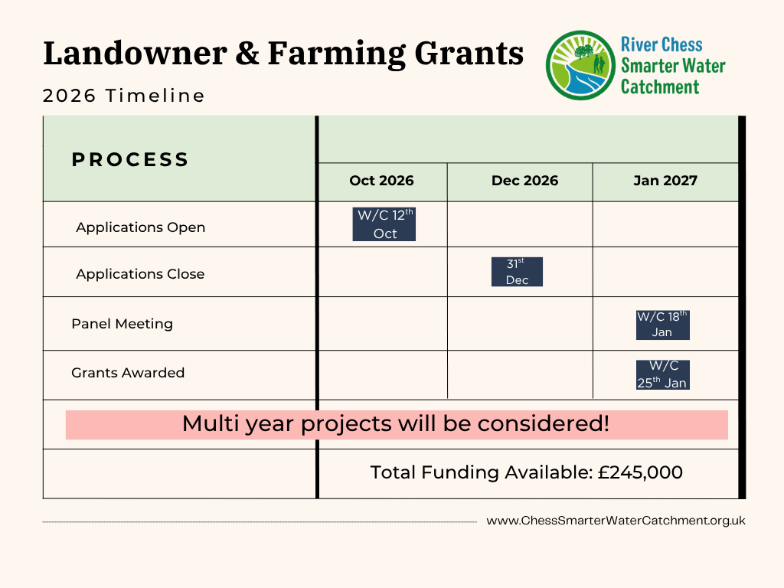

All references to ‘your’ means the applicant

